**Hackathon Day 5**

*Varun Ullanat (*[*varunullanat.bt17@rvce.edu.in*](mailto:varunullanat.bt17@rvce.edu.in)*)*

**Problem Statement 1**

A small Indian biopharmaceutical company would like to collaborate with a startup biopharmaceutical company in the US to set up infrastructure in India, for the development of a **Biosimilar** product (monoclonal antibody) from scratch, for the treatment of head and neck cancer.

Describe the regulatory pathway that the Indian biopharmaceutical company needs to follow to initiate this drug development, right from developing the clone, to manufacture, preclinical and clinical studies and finally market the product in India and USA.

Do keep in mind the local regulatory and ethical considerations for India, but also the requirements to market the biosimilar product in the USA.

**Solution:**

**1. Regulatory pathway for product approval according to government guidelines**

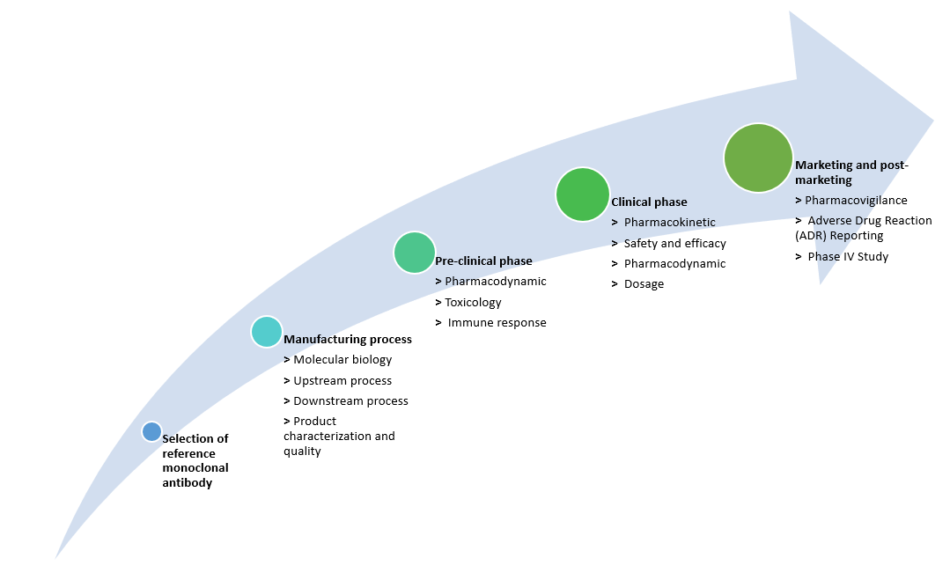

**2. Regulatory process**

**2.1 Selection of reference monoclonal antibody and cloning**

The following rules should be followed for selecting and cloning of the reference molecules:

1. *“The Reference Biologic should be licensed/approved in India or ICH countries and should be the innovator's product. The Reference Biologic should be licensed based on a full safety, efficacy and quality data”.* In this case, the reference molecule is already licensed in the U.S, which is an ICH country, by the parent company.
2. *“In case the Reference Biologic is not marketed in India, the Reference Biologic should have been licensed in any ICH countries”.* Point 1 applies here as well.
3. *“The same Reference Biologic should be used throughout the studies supporting the safety, efficacy and quality of the product (i.e. in the development Programme for the Similar Biologic)”.* The Indian start-up has to ensure that reference biologic is compared side by side with the biosimilars.
4. *“The active drug substance (active ingredient) of the reference biologic and that o Similar Biologic must be shown to be similar”.* Both the reference and the biosimilar contain monoclonal antibody as the core agent.
   1. **Manufacturing process** 
      1. **Molecular Biology aspects**

The following details should be presented in brief with figures:

1. Cell cultures
2. Vectors used
3. Gene sequences
4. PTMs
   * 1. **Upstream processing requirements**
5. Upstream process should be described in detail including media components used for cell growth.
6. At least three batches of reproducible fermentation data at pilot scale (batch size adequate to give enough purified product to generate preclinical data).
7. Upstream process should be well controlled and monitored.
8. Details of upstream process kinetics data from consistency batches indicating cell growth, product formation, pH, temperature, dissolved oxygen, major nutrient consumption pattern and agitation rate.
9. Concentration to be defined in terms of product/liter, yield and volumetric productivity.
10. Data to verify that the specific protein yield (amount of protein per unit cell mass) remains constant for all upstream batches.
11. Demonstrate that the overall productivity is reproducible and scalable.
    * 1. **Downstream processing requirements**
12. Detail description of the methods followed for the cell harvesting and extraction of the protein.
13. Steps involved in purification of protein.
14. Batch size for protein purification.
15. Description of each unit operation step during purification and recovery of protein along with quantitative recovery of product at each stage.
16. Describe the quality of the refolded protein if the starting material is aggregated or from inclusion bodies and include details of the refolding process specific activity at different doses, dose response curve, stability data and confirmation of solubility and absence of aggregation.
17. Consistency of recovery in three consecutive batches of purification from three independent batches of cell culture/fermentation.
18. Describe post translational variation, if any.
19. Details of removal of impurities like product related variants & impurities, and host cell& process related impurities considered to pose a risk of Immunogenicity (EMEA1997).
20. Virus clearance validation studies.
    * 1. **Product characterization and quality requirements**

Further details about the product are required in case of clinical trials as prescribed by CDSCO according to the Good Manufacturing Practices:

1. Detailed description of the drug substance and drug product processes
2. Critical and key Quality Attributes of the product
3. Manufacturing process controls
4. Critical process parameters
5. Stability data
6. Comparability of product manufactured at clinical scale against Reference Biologic
7. Data from consistency batches and/or process validation batches as applicable.

CDSCO also places importance on the quality assurance of the biosimilars product and takes into consideration the following parameters:

1. Analytical methods to measure product features has to be reproduceable and reliable.
2. The characterization studies should include samples of the applicant's r-DNA derived product, Reference Biologic as control, known positive standard and negative control, wherever relevant.
3. To ensure the statistical analysis, each quantitative experiment should be done at least three times and data should be represented in terms of mean and standard deviation. Appropriate statistical significance should be represented throughout the characterization data.
4. Characterization studies for Similar Biologics including physicochemical properties, Biological activity, immunological properties, functional assays, purity, strength and content should be one.
5. Principles outlined in the ICH Q6B guideline should be followed. Indian Pharmacopoeia Monograph should be followed, if available.
6. Acceptance limits should be set based on Reference Biologic data and data from sufficient number of batches from preclinical or clinical batches, which must be in line with international norms.
7. The shelf-life and storage condition of drug substance and drug product should be assigned based on real-time stability studies. Stability studies on drug substance and drug product should be carried out using containers and conditions that are representative of the actual storage containers and conditions, according to relevant guidelines (e.g. ICH Q1 A(R2), ICH Q5C, WHO TRS 822)

**2.3 Pre-clinical phase**

“*The applicant has to comply with the RCGM requirements like demonstration of consistency of the process and product, product characterization and product specifications. The applicant should submit the data generated along with the following basic clinical information and preclinical study protocols to RCGM for obtaining permission*”.

Basic information for the reference biologic and the biosimilars has to be given:

1. For reference biologic: Route of administration, absorption and elimination rate, therapeutic index, dose, vehicle, mode of administration, dose response, bioequivalence range, mode of action, toxicity and tissue localization
2. For biosimilars: Known clinical use, target population, dosage, route of administration, diluents, composition and formulation, adjuvants and packaging form

*“The application to RCGM should be accompanied by approval of Institutional Bio Safety Committee (IBSC) of the developer and approval of* *Institutional Animal Ethics Committee (IAEC)”*

As part of the pre-clinical phase, the following analysis and comparison of the same with reference biologic are required to get approval:

1. Pharmacodynamic studies including in-vitro and in-vivo to evaluate Biological activity
2. Toxicology studies on animal models to evaluate the ill-effects of the drug. It should follow guidelines set by Institutional Animal Ethics Committee
3. Immune response evaluation to test the serum of animal for reaction to host cell proteins.
4. Other toxicity studies, including safety pharmacology, reproductive toxicity, mutagenicity and carcinogenicity studies are not generally required for evaluation of a Similar Biologic unless warranted by the results from the repeated-dose toxicological studies

*“Based on the successful evaluation of preclinical study reports, RCGM will recommend the DCG(I) to allow the company to conduct appropriate phase of clinical trial as per the CDSCO requirements. The applicant may submit parallel application to RCGM and office of DCG (I) seeking approval to conduct clinical trial”.*

* 1. **Clinical phase**

*“Besides the information submitted in the preclinical application, the applicant has to submit application for conduct of clinical trial as per the CDSCO guidance for industry, 2008. The quality data submitted should indicate that there are no differences in Critical Quality Attributes (CQAs), and that all Key Quality Attributes (KQAs) are well controlled in order to allow the initiation of clinical evaluation”.*

* + 1. **Pharmacokinetic Studies**

The Pharmacokinetic study of the Biosimilars in comparison with the Reference Biologic product may be performed in an appropriate number of healthy volunteers and patients with the disease, i.e. head and neck cancer. These studies should take into consideration half-life, linearity of PK parameters, endogenous levels of Biologic under study, route of administration and disease indications. It usually involves two types of studies on the basis of dosage:

1. Single Dose: Dosage in the PK study should be within the therapeutic dose range of reference Biologic. Appropriate rationale for dose selection should be provided. The analytical method should be validated to have satisfactory specificity, sensitivity and a range of qualification with adequate accuracy and precision.
2. Multiple Dose: Multiple-dose, comparative, parallel arm steady state PK studies are required for biosimilars that is used in a multiple dose regimen, where markedly higher or lower concentrations are expected at steady state than that expected from single dose data PK measurements, and where time-dependence and dose-dependence of PK parameters cannot be ruled out.
   * 1. **Pharmacodynamic Studies**

As required for the PK studies in the Similar Biologic clinical development program, the pharmacodynamic studies should also be comparative in nature.

*“The relationship between dose / exposure, the relevant PD marker(s) and response / efficacy of the Reference Biologic should be well established and used to justify the design. The acceptance ranges for the demonstration of Similarity in PD parameters should be predefined and appropriately justified. The parameters investigated in PD studies should be clinically relevant and surrogate markers should be clinically validated”.*

**2.4.3 Safety and Efficacy studies**

*“Information to establish comparative safety and efficacy in relevant patient population is mandatory for all Similar Biologics. Comparative clinical trials are critical to demonstrate the similarity in safety and efficacy profiles between the Similar Biologic and Reference Biologic with few exceptions. The study should be conducted in a sensitive and homogenous patient population with appropriate sensitive primary end points as per requirement of a Phase III clinical trial”*

The safety and efficacy studies should ensure that the biosimilars and the reference are similar in the following aspects:

1. Similarity with respect to quality
2. Similarity with respect to preclinical assessment
3. Clinical safety and efficacy
4. Mechanism of action is same
5. Involved receptor(s) are same
6. New indications not mentioned by innovator will needs to be covered by a separate application
   1. **Marketing and post-marketing**

*“The applicant should submit application for market authorization as per CDSCO guidance document for industry, 2008. For cases where commercial manufacturing is performed either at a different scale and/or with a different process as compared to that used for manufacturing phase III clinical trial batches, then information on comparability of quality needs to be additionally submitted with appropriate justification and will be dealt with on a case to case basis”*

After marketing of the biosimilars, it is important to carry out further studies to evaluate the long-term effects of the drug. The following analysis should be performed:

1. Pharmacovigilance: It is done to search for adverse reactions and side-effects not picked up in clinical studies. The pharmacovigilance plan should include the submission of periodic safety update reports (PSURs).
2. Adverse Drug Reporting: All cases involving serious unexpected adverse reactions must be reported to the licensing authority
3. Phase IV study: Involves collecting data from random patients who have taken the drug. Parameters such as safety, efficacy and immunogenicity should be considered.

*“The plan of post market studies should be captured in Pharmacovigilance plan and update on the studies should be submitted to the CDSCO”.*

* 1. **Regulatory agencies involved**

|  |  |  |  |
| --- | --- | --- | --- |
| **Step** | **Description** | **Agency** | **Application form** |
| **Selection of reference monoclonal antibody and cloning** | Permission for carrying out manufacturing | CDSCO | NOC form |
| **Manufacturing** | Manufacturing License for  test, analysis and  examination | State FDA | Form 30 |
| License for test,  analysis and examination | CDSCO -zonal | Form 12 |
| Carrying out Research and  Development | RCGM | Form C1 |
| **Pre-clinical** | Approval for pre-clinical studies | RCGM | Form C3a |
| Submission of Preclinical study report | RCGM | Form C5a |
| **Clinical trial** | Approval for clinical studies | CDSCO | Form 44 |
| **Product Manufacturing** | Import /Manufacturing and  marketing permission | CDSCO | Form 44 |
| Manufacturing License | State FDA | Form 27 D |
| Registration certificate for import | CDSCO | Form 40 |
| **Marketing** | Marketing permission /  License for imported product | CDSCO | Form 8 and 9 |

**Problem Statement 2**

An Indian startup company would like to develop a plant-based treatment for COVID-19. The novel product will be classified as Ayurvedic formulation and will follow AYUSH guidelines for development. Describe the requirements in details and the regulatory pathway to be followed by the company to successfully develop and market this product in India.

Solution:

**1. Regulatory pathway**

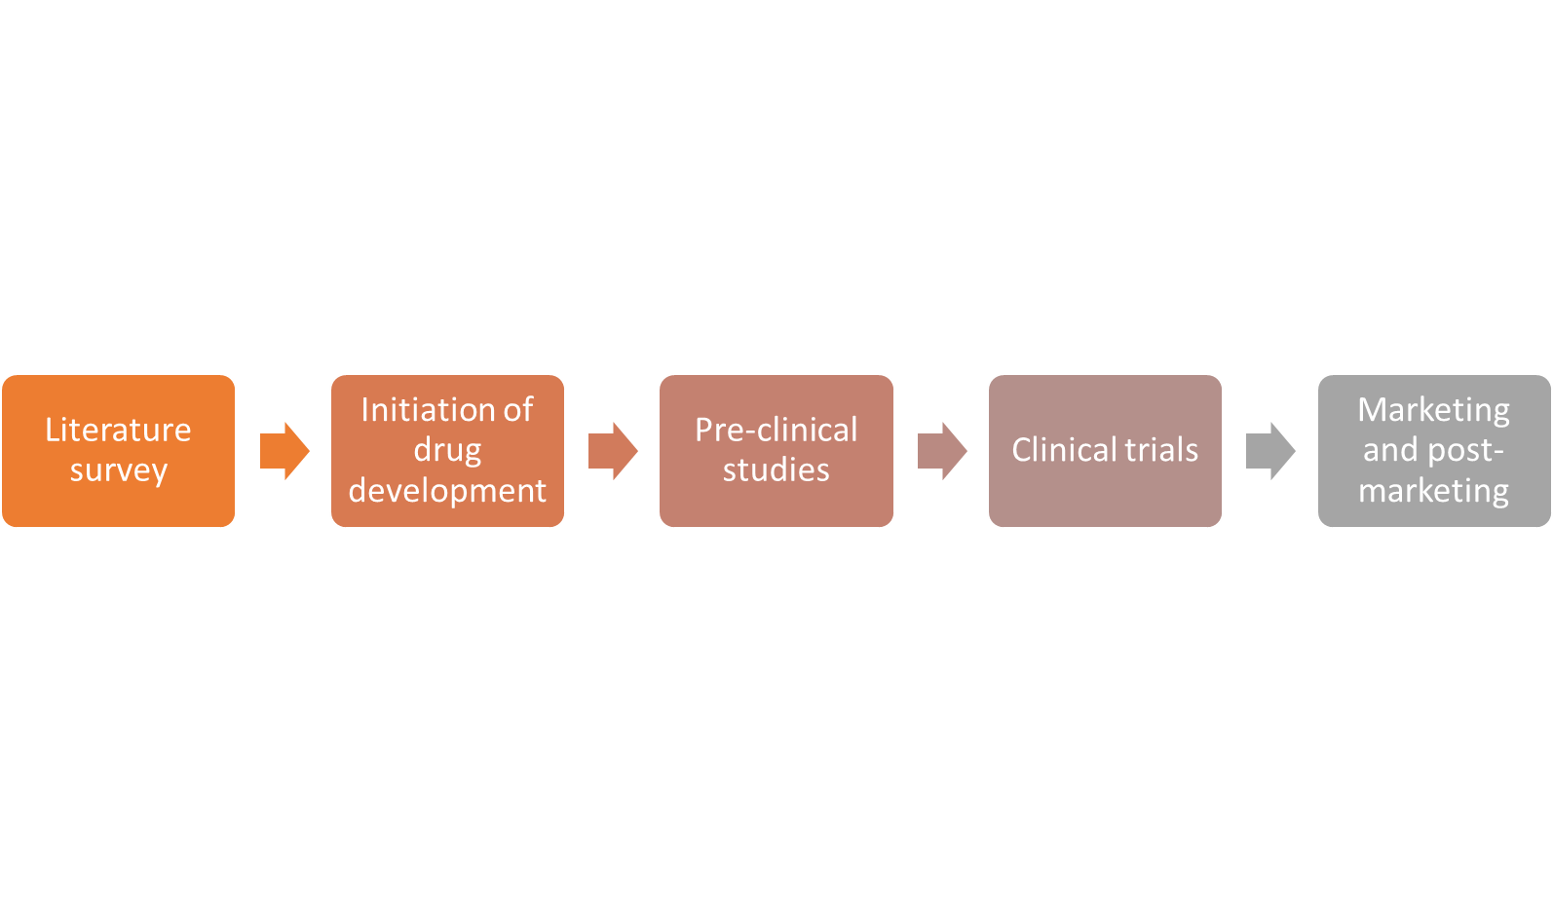

**2. Regulatory process**

**2.1 Literature survey**

Involves gathering information about the type of ingredient to use by screening for effect against the desired target, i.e. COVID-19. The details are gathered from:

1. Previous clinical data of ingredients
2. Classical evidences
3. Folklore
4. Active ingredient search
5. Screening of natural compounds

**2.2 Initiation of drug development**

After the active ingredient is identified, a series of tests have to be conducted to get a rough idea about product composition and dosage. This includes various parameters like:

1. Botanical identification
2. Drug standardization by evaluating biological properties
3. Considering classical and current methods for preparation
4. Safety and efficacy studies
5. Initial formulation
   1. **Pre-clinical studies**

The pre-clinical studies involve various biological and chemical analysis methods so as to derive the most effective version of the drug. These typically involve:

1. Pharmacodynamic studies
2. Pharmacokinetic studies
3. ADME studies
4. Toxicity studies
5. Testing on animal models with appropriate ethical clearances

**2.4 Clinical studies**

After determining the dosage and final formulation of the drug, necessary approval from IEC/IRB is required to carry out clinical trials on human subjects. A clinical trial is composed of the following steps:

1. Trial conduction
2. Trail monitoring
3. Trial coordination
4. Data analysis
5. Publication

**2.5 Marketing and post-marketing**

After marketing of the biosimilars, it is important to carry out further studies to evaluate the long-term effects of the drug. The following analysis should be performed:

1. Pharmacovigilance
2. Adverse Drug Reporting
3. Phase IV study

**Problem Statement 3**

Do you think there will there be a single therapy/drug/vaccine to tackle and overcome SARS-CoV-2 / COVID-19? Describe the different/multiple methodologies and drug development strategies, that are currently been developed by scientists and researchers globally to treat COVID-19.

**Solution:**

The chance of developing a “silver bullet” or a drug that can cure COVID-19 by itself is highly unlikely in the near future. Hence scientists and researchers have to look at various types of treatments to keep COVID-19 in check and to stop its spread.

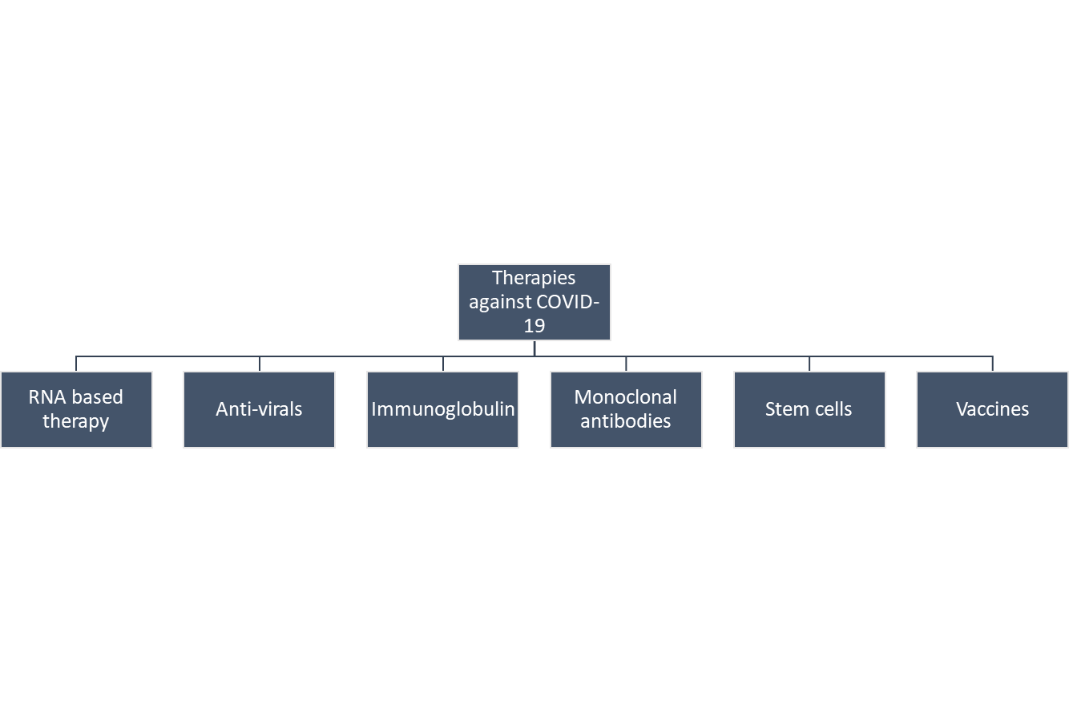

**1. Anti-viral drugs**

Antiviral drugs are a class of medication used for treating viral infections. Most antivirals target specific viruses, while a broad-spectrum antiviral is effective against a wide range of viruses. Unlike most antibiotics, antiviral drugs do not destroy their target pathogen; instead they inhibit its development*.* Many researchers are screening the pool of approved anti-viral drugs to test their efficacy on COVID-19. Many such candidates have been analyzed, like Remdesivir, Hydroxychloroquine, Lopinavir and Dexamethasone for complete or partial treatment. At the same time researchers around the world are trying to synthesize drugs that specifically target the molecular mechanisms of coronavirus, such as:

* Preventing SARS-CoV-2 from entering lung epithelial cells
* Help manage the disease with general anti-inflammatory drugs
* Assess the efficacy of drugs as post-exposure prophylaxis
* Evaluate the rate of co-infections among COVID-19 critically ill
* Reduce symptoms by targeting inflammatory mediators (with a humanized anti-interleukin-6 receptor monoclonal antibody)
* Prevent hypercoagulation

**2. Immunoglobulin therapy**

Immunoglobulin therapy involves injecting patients affected by COVID-19 with the antibodies produces by survivors of the virus. Using technology and processes already well-established in the fights against other indications, we can harvest the blood plasma of donors who have fully recovered from COVID-19, purify the Ig and distribute it to those in need, quickly and with dramatically improved patient outcomes. From previous studies, we know that they pose little risk to patients, which could help to streamline the regulatory approval process. But there are conflicting reports about the efficacy of this treatment. Many patients who have previously recovered from COVID-19 have been re-infected again, suggesting that the antibodies against it are not very effective. The treatment also depends on the availability of large amounts of serum from recovered patients, and the time-frame for administration is very short. Clear demonstration of therapeutic benefit will require well controlled studies.

**3. Monoclonal antibodies**

Monoclonal antibodies (mAb) are antibodies that are made by identical immune cells which are all clones belonging to a unique parent cell. Many researchers are turning to monoclonal antibodies as a treatment against COVID-19. Similar to immunoglobulin therapy, mAb presents relatively little risk to patients, which means a mAb product could move quickly through the regulatory pipeline. mAb is produced in bioreactors by genetically modified mammalian cells, which means that manufacturers could ramp up production more easily in the event of a future outbreak. Several studies have already identified neutralizing antibodies against COVID-19 as a potential component of protective immunity. However, only a handful of studies to date have focused on evaluating the efficacy of convalescent plasma with antibodies to protect or prevent COVID-19 infection in vivo. One limitation of mAb’s for treating the infection is that its production is very expensive, and so poorer countries may not be able to benefit from it.

**4. Vaccines**

The best long-term solution in fighting COVID-19 is with the use of vaccines. The pathway towards vaccine development is long, with many branching paths. The historical approach is to propagate a mammalian cell culture, infect it with the actual SARS-CoV-2 virus under appropriate biosafety containment conditions, then isolate and chemically inactivate the virus. This is followed by purification, formulation and filling to produce the final dose form of the vaccine. Another “live viral” vaccine approach is to genetically modify the virus itself, attenuating and rendering the virus non-pathogenic throughout its lifecycle. Both approaches could trigger the necessary immune response in healthy individuals. Both have their advantages and disadvantages. Both are commonly used in producing today’s vaccines. A third prevalent approach is a subunit vaccine, in which a non-pathogenic fragment of the virus, typically a surface protein without any DNA or RNA, is used to trigger an antigenic immune response and stimulate acquired immunity against the virus. Other possible strategies include DNA plasmid vaccines and recombinant vector vaccines. The challenge for developing vaccines is the it’s hard to collapse the timeline required for necessary safety and efficacy testing. Since most vaccine candidates fail in the clinic, it’s crucial to test multiple strategies.

**5. Cell based therapy**

More recently, a growing number of clinical investigations of cell-based therapies, primarily involving mesenchymal stem (stromal) cells (MSCs), but also utilizing MSC-derived conditioned media (CM) or extracellular vesicles (EVs) and several other cell types, have been initiated for COVID-19. Stem cells exert their immunomodulatory, anti-oxidant, and reparative therapeutic effects likely through their EVs, and therefore, could be beneficial, alone or in combination with other therapeutic agents, in people with COVID-19. There are currently 17 clinical trials evaluating the therapeutic potential of MSCs for the treatment of COVID-19, the majority of which are administered intravenously with only one clinical trial testing MSC-derived exosomes via inhalation route.

**6. RNA based therapy**

Innate RNA interference (RNAi) mechanism can be employed to develop front line therapies against the virus. This approach allows specific binding and silencing of therapeutic targets by using short interfering RNA (siRNA) and short hairpin RNA (shRNA) molecules. RNAi against COVID-19 disease can potentially be directed against two different categories of targets: viral proteins essential in survival and replication of COVID-19 virus, and host factors involved in cellular entry and trafficking of the virus. To implement RNAi, most studies concentrated on the shRNA, where the short interfering RNAs are derived from plasmid-based expression systems, due to practical aspects of conducting the initial proof-of-principle studies. This system is convenient to implement (especially in easy-to-transfect cell lines), more economical and allows stable expression of interfering RNA sequences. However, it is unlikely for the shRNA approach to be employed as a therapy. Most of these studies also focused on “prevention of infection” whereby the RNAi agents are induced first and then viral infection is attempted. It is more likely to demonstrate an efficacy in this kind of a set-up but the clinical reality is the reverse; the patients are already infected with the COVID-19 before the RNAi agents need to be administered.